REPORT OF ATAL COMMUNITY DAY

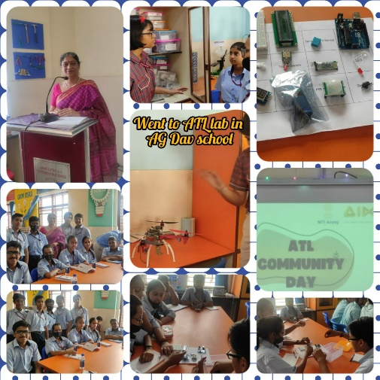
Creativity is thinking up new things and Innovation is doing new things.

Atal innovation mission has an objective of fostering curiosity, creativity and imagination in young minds and to inculcate skills such as design mind set, computational thinking, adaptive learning etc.
AG DAV Model Town celebrated Atal Community Day on Tuesday, 16/5/23 inviting students from other schools to experience the taste of innovation by doing activities. Eleven students of class IX from our school participated in various activities conducted by them in the Atal Lab. Some of the activities were: Test your memory, Connecting the dots and Bob the builder. This event was a fruitful way of nurturing innovation and creativity by collaboration. The students also got an opportunity to see their inventory, working of 3-D printer and flying of a drone which is specially used in the field of defence.

-

